EXPERIMENT NO. 7
Student Attendance System using Zoho Creator (SaaS)

AIM
To develop a cloud-based Student Attendance System using Zoho Creator for maintaining attendance records.

INPUT AND OUTPUT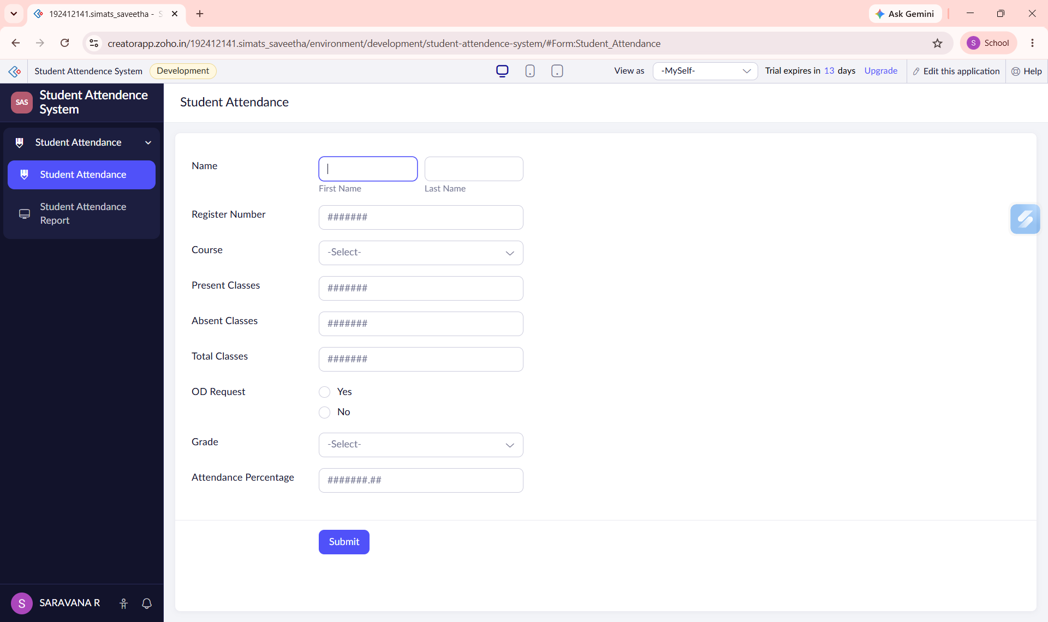
Figure 1: Attendance Form
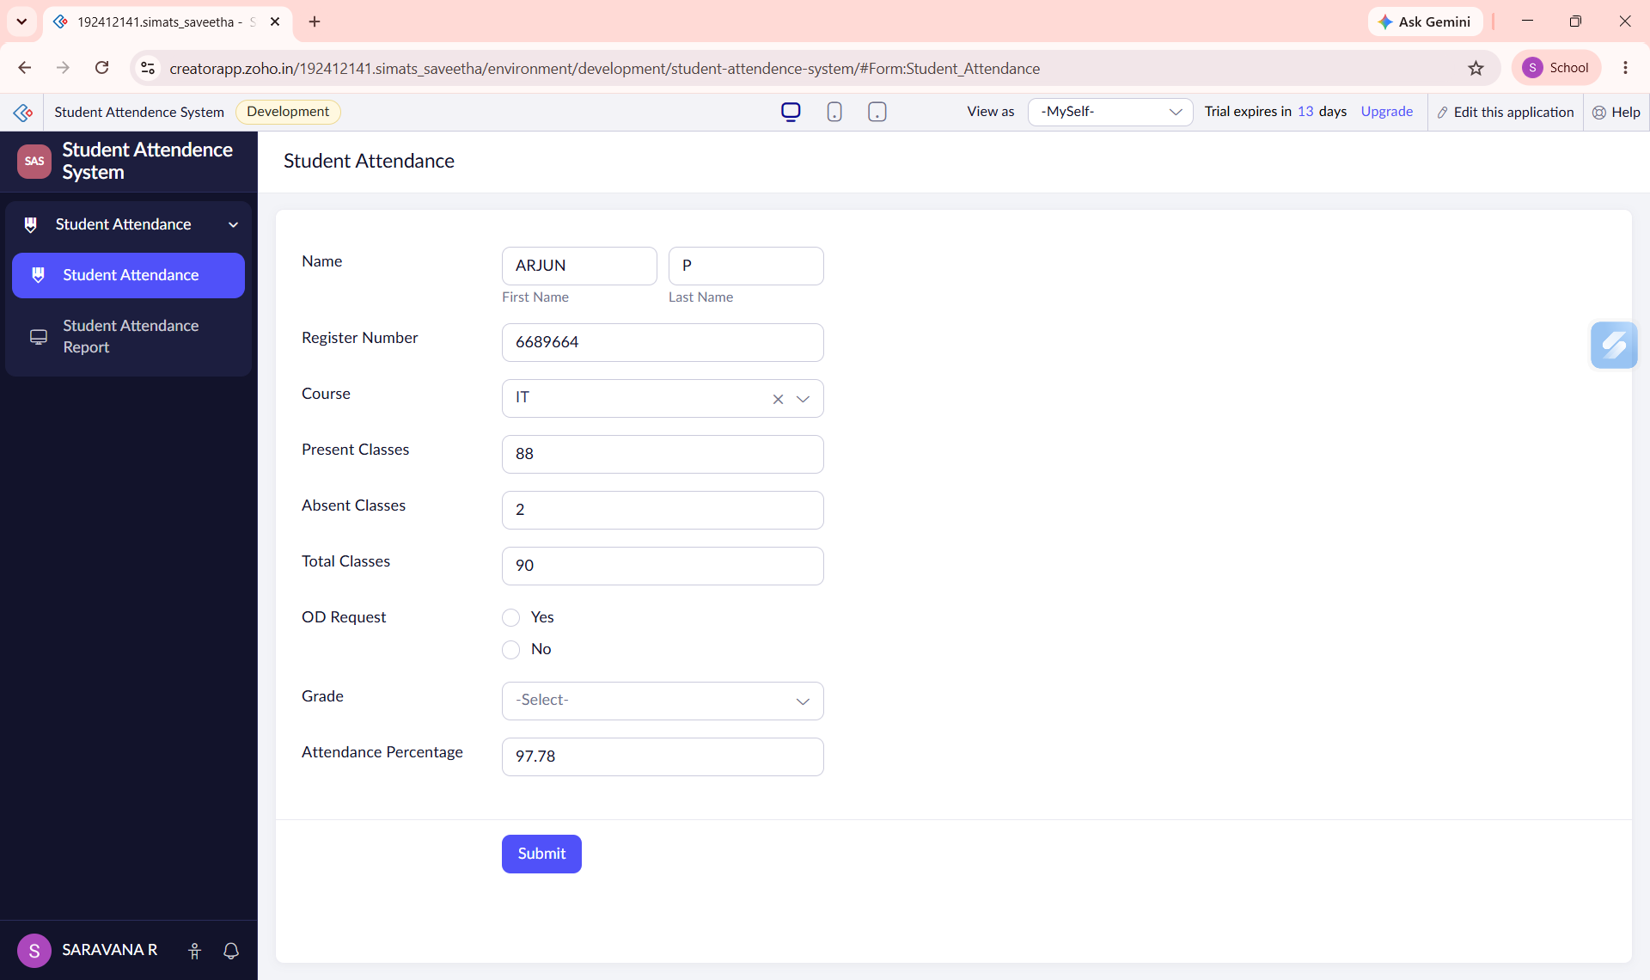
Figure 2: Filled Form
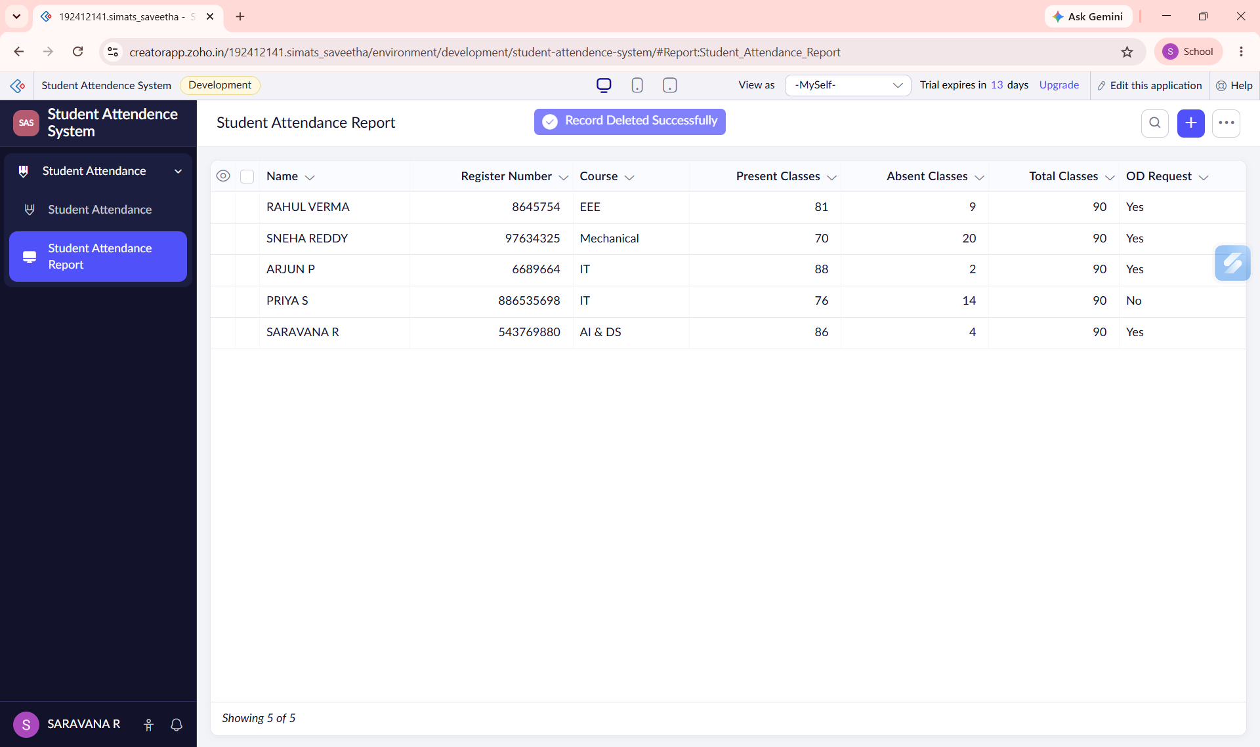
Figure 3: Attendance Report
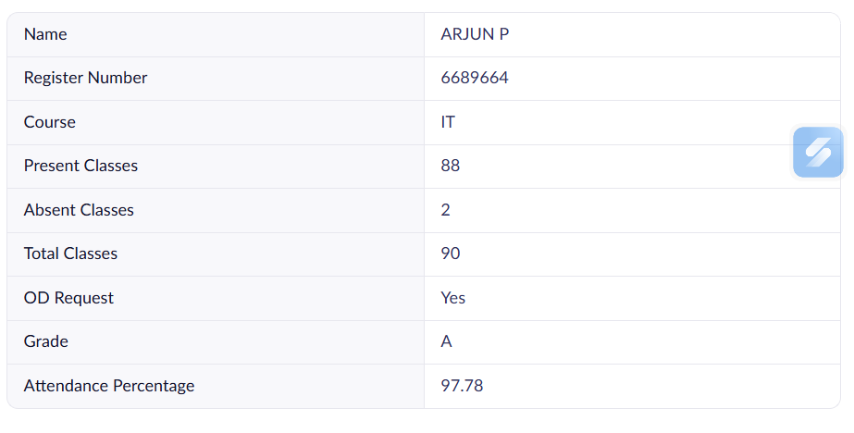
Figure 4: Individual Record

RESULT
The Student Attendance System was successfully implemented using Zoho Creator.

